2018 Australasian Management Challenge

Business Case

Background
This paper outlines a compelling case for our council to enter a team in the Australasian Management Challenge in 2018.

It outlines the benefits to the participants and the organisation, any other considerations and the costs.

The Management Challenge has been run annually for more than 25 years and is the most enduring, successful, targeted professional development program for local government. Many former participants and mentors have gone on to become senior council executives. A large number of current CEOs are former Management Challenge participants.

The Management Challenge is a simulation-based team building, learning and networking program using real local government themes – the types of issues that a senior management team in a council would most likely face.

The teams are challenged to respond to a series of tasks in a unique one-day, fast paced, “pressure cooker” environment. Some tasks will require written responses (such as a council report or recommendation document), some will take the form of role plays or presentations and the teams are also scored on observations of how well they display energy, synergy, effectiveness and creative thinking.

It provides an opportunity for team members to develop their skills and become more effective in the way they:

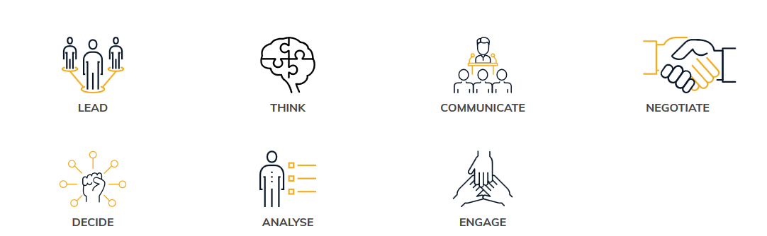

Provider
The Management Challenge is the flagship program offered by Local Government Professionals Australia, and is delivered in each state, territory (and New Zealand) by their federation partners.

LG Professionals Australia was founded in 1936 and has been providing thought leadership, knowledge sharing, professional development and networking for local governments in Australia since that time.

More than 100 teams participate annually in the Management Challenge across Australia and New Zealand.

What resources are provided?
Once registered, teams gain access to a wide range of resources to enable them to prepare for the Management Challenge, including the following downloadable guides:

- Getting Started
- Forming a Composite Team
- Participants Handbook (upon registration)
- Mentors Handbook (upon registration)
- Brochure and Promotional poster to assist with recruiting your team

How does the organisation benefit?
A recent review of the Management Challenge in 2017 included interviews and focus groups with council CEOs who have entered teams in the Management Challenge. They summarised the benefits to their organisations as follows:

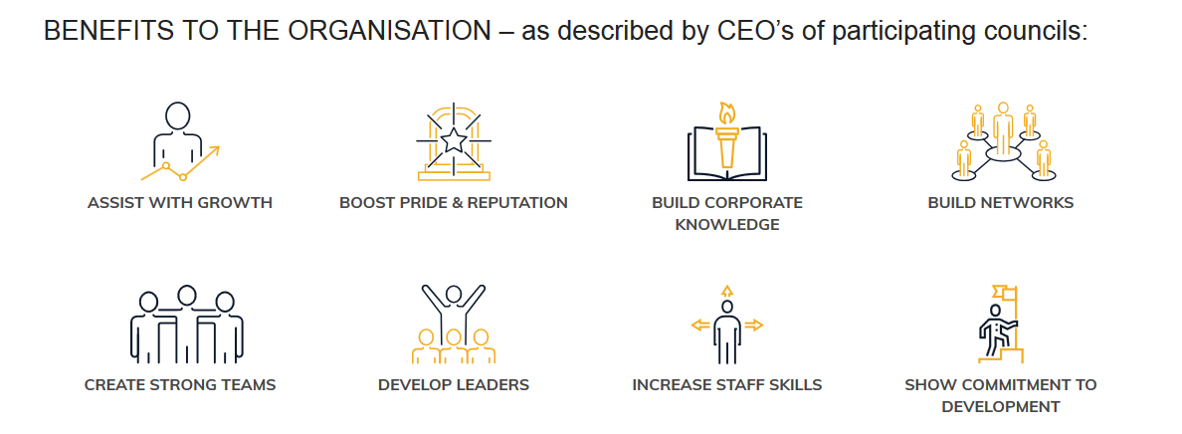

CEO’s and HR Managers told us the benefits to the organisation are:

- Assists with growth of individuals and teams
- Boosts pride in the organisation and builds a positive reputation
- Builds corporate knowledge
- Builds networks and break down silos
- Creates strong teams (that can also be used after the Management Challenge as project resource)
- Develops leaders – especially emerging leaders
- Increases staff skills through new challenges and putting people outside of their comfort zone
- Shows commitment to development - the challenge is a very public way to show the organisation is committed to staff development

The Management Challenge website includes a short video interview with Mark Withers, CEO of the City of Port Adelaide Enfield, speaking about the benefits of the Management Challenge. You can find it at www.managementchallenge.com.au

How does the participant benefit?
Surveys with recent participants distilled the main benefits they received:

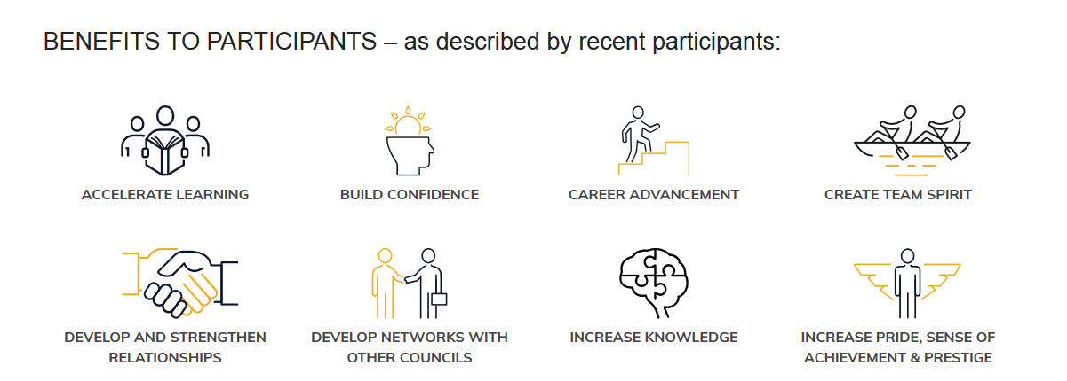

Recent participants told us the benefits to them included:
- Accelerates their learning through a fast-paced, relevant program
- Builds their confidence by getting them to learn new skills and placing them in new situations
- Advances their career – the challenge ensures they form relationships with senior management and improves their profile in the organisation
- Creates team spirit – working alongside their team mates toward a common goal;
- Develops and strengthen relationships across the organisation and across the sector
- Develops networks with other councils through interaction with other teams
- Increases knowledge of the organisation and local government
- Increases pride in the organisations, in themselves, and a sense of prestige of representing their council in a competitive environment.

The Management Challenge website include a short video interview with Wayne Redden, WHS Coordinator at the City of Port Adelaide Enfield, a recent participant, speaking about the benefits of the Management Challenge. You can find it at www.managementchallenge.com.au

Are there any other benefits to the organisation?
Yes, organisations appoint mentors (usually managers, or prior Management Challenge participants) to assist their team to prepare for the Management Challenge. This process engages many council staff in the program, giving opportunities for council staff to share their experience and ideas with the teams.

Recent mentors provided feedback about the benefits they see from the program:

Recent mentors told us the benefits to them included:
- Builds confidence in themselves by sharing their skills and experience with others
- Enhances their leadership skills through management of the development of the team
- Increases pride in their organisation, in themselves a sense of prestige in mentoring their council team
- Raises their profile in the organisation and with senior management

Also, the Pre-Challenge task, to be completed prior to the Management Challenge Day, is based on real-world council issues and programs, including a community consultation element. Many of the Pre-Challenge tasks completed last year went on to receive council funding and delivered real community outcomes.

Will it enable participants to do their jobs better?
Yes, participants speak about their increased confidence, a more positive approach to their roles and to the organisation and an increased sense of pride.

In addition, the knowledge gained makes them more knowledgeable about local government generally and more able to deal with unexpected situations.

What happens after the training – are there ongoing benefits?
Yes, many councils continue to keep their teams together after the event, as a cross-functional resource for council projects or issues.

Also, the pre-challenge task also delivers a valuable insight, report and resource for the community.

Can these benefits be measured?
Yes, depending on your council KPI’s and measures. Certainly, participants learn a new level of time management and often mention that they are more able to manage stressful situations. The consultation performed during the pre-challenge task is also highly valuable, being done in house with a very targeted approach which is cost-effective.

What are the costs?
The early bird team fee is: $5,200 (ex GST) The regular team fee is: $5,600 (ex GST)

To be eligible for the early bird fee payment must be made by 15 December 2017.

How does this compare to other alternatives?
The Management Challenge is very good value. The entry fee covers the participation of all team members (5-6) and also travel costs to attend the national final (should the team win the regional challenge).

To provide similar training and experience to all team members individually, would require sending each team member on a whole range of training programs which would of course be much more expensive. To achieve this, it would probably cost in excess of the Management Challenge entry fee ($5,200 early bird) per person!

Further no other training program in Local Government or beyond has such an intensive action learning focus combined with the opportunity to network with peers and leaders from across the sector.

What other considerations/risks?
Team members will be involved in preparation sessions, mentoring and (up to your council) even a mock challenge to be held in house.

Accordingly, this will take the team members away, to some degree, from their daily roles for short periods of time, and of course the Management Challenge Day itself is a whole day.

But the preparation time is not onerous and should be able to be effectively managed by managing workloads (as is the case when any council staff are involved in training or even just attending meetings)

Recommendation
It is recommended that the council enter a team in the 2018 Management Challenge, and begin to recruit our team as soon as possible to enable the maximum time for preparation.

More information

For more information on the Management Challenge please see the Management Challenge website, managementchallenge.com.au or contact the Program Manager, Jane Trotter, at challenge@lgprofessionalsaustralia.org.au
02 6169 4190

